**Report**

**On**

**ShopNest Store Capstone**

**By**

**Sandeep Katakiya**

**Introduction to ShopNest Store**

ShopNest Store is a leading department store in Portugal's thriving e-commerce business. ShopNest is a major platform that connects small companies from all across the nation with a variety of online sales platforms. ShopNest helps small businesses sell their goods more effectively by centralizing the process under a single point of contact.  
  
ShopNest's dedication to helping small companies is the foundation of its business model. The platform offers retailers a smooth interface for product presentation, guaranteeing that each item receives the attention it merits. ShopNest's logistics partners enable direct distribution to consumers, providing even more ease for merchants, allowing them to concentrate on their core competencies of crafting and selecting remarkable items.

ShopNest Store is a vital partner for small businesses trying to increase their market share and revenue because to its strong infrastructure and intuitive platform. Customers may access a wide variety of items through ShopNest, all while assisting small companies and boosting the Portuguese economy.  
  
ShopNest Store is transforming the Portuguese e-commerce market with a commitment to quality, customer happiness, and community support. This makes it simpler than ever for small companies to prosper in the digital era.

**1.Top Categories by Total Price:**

* Identify and visually represent the top 10 product categories by total sales

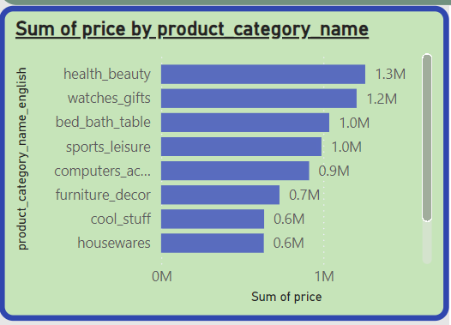

**Sum of price by product category name**

The bar chart provides a detailed breakdown of total sales across different product categories. Here are the values and insights:

* **Health & Beauty:** 1.3M
  + Highest sales category, indicating a strong customer preference and high demand. This category should be prioritized in inventory management and promotional strategies.
* **Watches & Gifts:** 1.2M
  + Second highest, showing significant customer interest. It suggests potential for gift-related promotions and special occasions marketing.
* **Bed, Bath & Table:** 1.0M
  + High sales indicate importance in home goods. Focus on seasonal promotions (e.g., holiday sales) could boost further sales.
* **Sports & Leisure:** 1.0M
  + Equal to Bed, Bath & Table, indicating a balanced interest in leisure activities. Summer and holiday seasons might see a spike in this category.
* **Computers & Accessories:** 0.9M
  + High-tech and accessories market showing substantial demand. Consider highlighting during tech events or back-to-school promotions.
* **Furniture & Decor:** 0.7M
  + Moderate sales, potential for growth with targeted home improvement campaigns.
* **Cool Stuff:** 0.6M
  + Lower compared to others, indicating niche interest. Specialty promotions might help in increasing visibility and sales.

**2.Delayed Orders Analysis:**

* + Determine the number of delayed orders in each category. An order is considered delayed if the actual delivery date is later than the estimated delivery date.

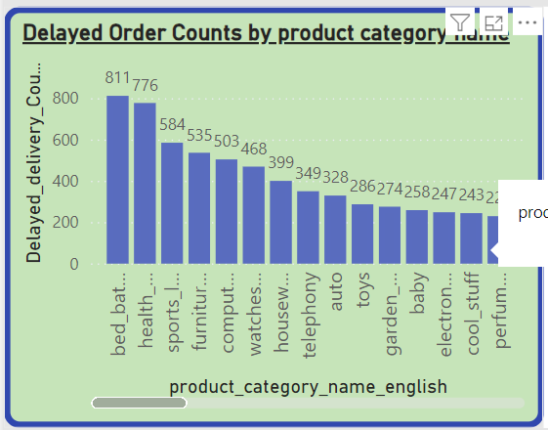

**Delayed order count by product category name**

1. **bed_bath_table**:
   * Delayed Orders: **811**
   * Insights:
     + Highest number of delayed orders, indicating potential issues in supply chain, inventory management, or logistical challenges.
2. **health_beauty**:
   * Delayed Orders: **776**
   * Insights:
     + High number of delays, similar to bed_bath_table, suggesting possible fulfillment issues.
3. **sports_leisure**:
   * Delayed Orders: **584**
   * Insights:
     + Moderate delays, indicating some inefficiencies in order processing or delivery.
4. **furniture_decor**:
   * Delayed Orders: **535**
   * Insights:
     + Significant delays, potentially due to the bulky nature of items and logistical challenges.
5. **computers_accessories**:
   * Delayed Orders: **503**
   * Insights:
     + Delays could be related to high demand or issues in supply chain coordination.
6. **watches_gifts**:
   * Delayed Orders: **468**
   * Insights:
     + Notable delays, possibly due to specific handling or packaging requirements.
7. **housewares**:
   * Delayed Orders: **399**
   * Insights:
     + Moderate delays, indicating potential for improvement in delivery processes.
8. **telephony**:
   * Delayed Orders: **349**
   * Insights:
     + Fewer delays compared to other categories, suggesting relatively efficient processes.
9. **auto**:
   * Delayed Orders: **328**
   * Insights:
     + Similar to telephony, fewer delays, indicating better logistics management.
10. **toys**:
    * Delayed Orders: **286**
    * Insights:
      + Lower delays, suggesting efficient order processing and delivery.
11. **garden_tools**:
    * Delayed Orders: **274**
    * Insights:
      + Fewer delays, indicating effective logistics and inventory management.
12. **electronics**:
    * Delayed Orders: **258**
    * Insights:
      + Relatively few delays, suggesting efficient handling and delivery processes.
13. **baby**:
    * Delayed Orders: **247**
    * Insights:
      + Lower number of delays, indicating a well-managed supply chain for these products.
14. **cool_stuff**:
    * Delayed Orders: **243**
    * Insights:
      + Few delays, suggesting effective management in this category.

* **Delayed Orders**: Categories such as bed_bath_table and health_beauty have high delayed order counts, indicating the need for improvement in supply chain and logistics. Addressing these delays can lead to better customer satisfaction and potentially higher sales.
* **Consistent Performance in Lower Delays**: Categories like cool_stuff, baby, and electronics have relatively few delays, indicating efficient operations in these areas. Best practices from these categories can be applied to improve performance in categories with higher delays.

**3.Monthly Comparison of Delayed and On-Time Orders:**

* + Create a dynamic visual that compares the number of delayed orders to the number of orders received earlier for each month. Utilize the drillthrough cross-report feature to provide a detailed analysis of late and on-time deliveries.

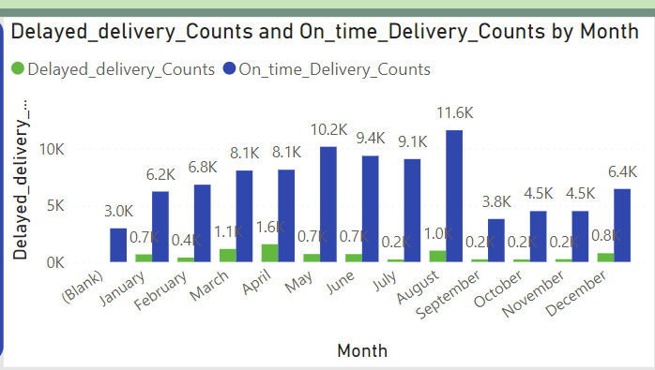

**Higher On-time Delivery Months**

1. **June**
   * **On-time Deliveries**: 10.2K
   * **Delayed Deliveries**: 0.7K
   * **Insight**: June has a peak in on-time deliveries with minimal delays, indicating very efficient operations and handling of orders.
2. **July**
   * **On-time Deliveries**: 9.4K
   * **Delayed Deliveries**: 0.2K
   * **Insight**: July maintains high on-time deliveries with an even lower number of delays compared to June, reflecting excellent logistical performance.

**Lower On-time Delivery Months**

1. **March**
   * **On-time Deliveries**: 6.8K
   * **Delayed Deliveries**: 1.1K
   * **Insight**: March shows a moderate number of on-time deliveries but a noticeable increase in delays, indicating some operational challenges.
2. **October**
   * **On-time Deliveries**: 3.8K
   * **Delayed Deliveries**: 0.2K
   * **Insight**: October has a significant drop in on-time deliveries, likely due to seasonal factors or reduced demand. However, the delayed deliveries remain low, suggesting manageable operational issues.

**Challenges in Specific Months**:

* **March, October, and November** display lower on-time delivery counts, indicating periods where operational performance might be challenged by various factors such as increased order volumes, seasonal variations, or logistical inefficiencies.

**Peak Operational Efficiency**:

* **June, July, and September** showcase the highest on-time delivery counts with minimal delays. These months indicate periods of peak operational efficiency. The effective handling of orders during these months suggests that logistical processes and supply chain management are highly optimized during these periods.

**4.Payment Method Analysis:**

* + Analyze the most frequently used payment methods by customers using a visually appealing representation, such as a pie chart or other suitable visuals.

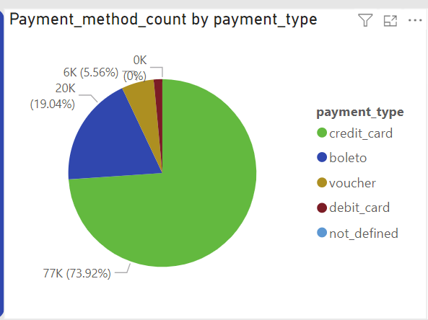

**Payment method count by payment type**

The pie chart illustrates the distribution of payment methods among customers:

* **Credit Card:** 77K (73.92%)
  + Dominant payment method, showing customer preference for credit transactions. Ensuring robust security and ease of use for credit card payments can enhance customer experience.
* **Boleto:** 20K (19.04%)
  + Significant portion of transactions, indicating the importance of supporting local payment methods. Could be a focus area for targeted promotions.
* **Voucher:** 6K(5.56%)
  + Lesser but notable usage. Vouchers might be popular for gift purchases or promotional events. Consider expanding voucher-based promotions.
* **Debit Card:** 1.5K (1.48%)
  + Minimal usage, suggesting either a lower preference or lesser acceptance. Investigate potential barriers and opportunities for growth.
* **Not Defined:** 0K(0.00%)
  + No undefined payments, indicating good data integrity in payment method tracking

**Payment method**

* **Dominant Method (Credit Card) vs. Least Used Method (Debit Card):**
  + **Credit Card**: 77K (73.92%) vs. **Debit Card**: 1.5K (1.48%)
  + The preference for credit cards is overwhelming. The negligible usage of debit cards might indicate a need to understand customer preferences better or improve the payment infrastructure for debit card users.
* **Local Payment Method (Boleto):**
  + **Boleto**: 20K (19.04%)
  + Significant local payment method usage suggests that accommodating local payment preferences is crucial. Tailored promotions or discounts for Boleto users could further encourage its use.

**5.Product Rating Analysis:**

* Determine the top 10 highest-rated products and the bottom 10 lowest-rated products using a bar or column chart

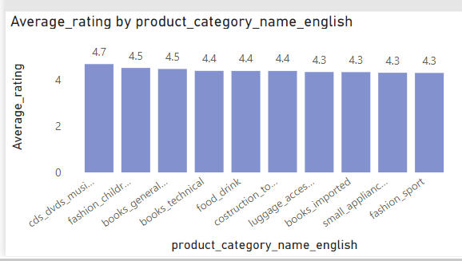

**Average rating by product category (top categories)**

1. **cds_dvd_musicals**:
   * Average Rating: **4.7**
   * Insights:
     + Highest customer satisfaction, indicating excellent product quality and customer service.
2. **fashion_child**:
   * Average Rating: **4.7**
   * Insights:
     + Tied with cds_dvd_musicals, showing strong approval from customers. This category could be a key driver for repeat purchases.
3. **books_general_interest**:
   * Average Rating: **4.5**
   * Insights:
     + Slightly lower than the top two, but still indicates high satisfaction. Books are generally well-received, suggesting a good selection and quality.
4. **drinks**:
   * Average Rating: **4.4**
   * Insights:
     + Good customer satisfaction, indicating a reliable and desirable product range in this category.
5. **book_imported**:
   * Average Rating: **4.4**
   * Insights:
     + Similar to drinks, showing that imported books are well-liked by customers, possibly due to unique offerings.
6. **luggage_accessories**:
   * Average Rating: **4.3**
   * Insights:
     + Good ratings, indicating satisfactory product quality and functionality.
7. **small_appliances**:
   * Average Rating: **4.3**
   * Insights:
     + Consistent with luggage_accessories, suggesting reliable performance of small appliances.
8. **fashion_sport**:
   * Average Rating: **4.3**
   * Insights:
     + Similar to small_appliances and luggage_accessories, showing consistent customer satisfaction in this category.

**Overall insights:**

**Customer Satisfaction**:

* + Top categories with high ratings (4.3 to 4.7) reflect strong customer satisfaction, likely due to good product quality, reliability, and customer service. Maintaining and enhancing these aspects can help retain customer loyalty.
  + Lower-rated categories, especially security_and_services with a rating of 2.5, need significant attention. Identifying the root causes of dissatisfaction, such as product defects, poor customer service, or unmet expectations, and addressing them can help improve ratings.
  + Categories with moderate ratings (3.6 to 3.9) have room for improvement. Enhancing product quality, expanding variety, and improving customer service can help boost satisfaction and potentially sales.

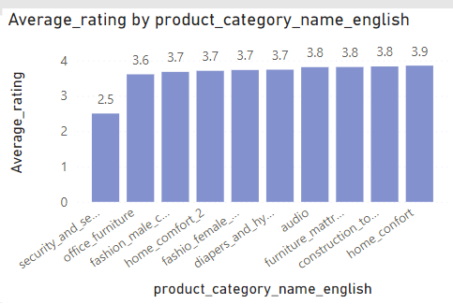

**Average Rating by Product Category (Lower Categories)**

1. **security_and_services**:
   * Average Rating: **2.5**
   * Insights:
     + Lowest rating, indicating significant customer dissatisfaction. This could be due to poor product performance, lack of reliability, or inadequate customer support.
2. **office_furniture**:
   * Average Rating: **3.6**
   * Insights:
     + Better than security_and_services but still relatively low. Issues could be related to quality, comfort, or durability.
3. **fashion_male**:
   * Average Rating: **3.7**
   * Insights:
     + Moderate satisfaction, suggesting some areas of improvement in product quality or variety.
4. **home_comfort_2**:
   * Average Rating: **3.7**
   * Insights:
     + Consistent with fashion_home, indicating similar levels of customer satisfaction and potential issues.
5. **furniture_mattress_and_upholstery**:
   * Average Rating: **3.8**
   * Insights:
     + Slightly higher than the previous categories, indicating better satisfaction but still room for improvement.
6. **audio**:
   * Average Rating: **3.8**
   * Insights:
     + Similar to furniture_mattress_and_upholstery, showing consistent performance and moderate satisfaction.
7. **construction_tools**:
   * Average Rating: **3.8**
   * Insights:
     + Consistent with audio and furniture_mattress_and_upholstery, indicating similar levels of customer satisfaction.
8. **home_comfort**:

* Average Rating: **3.9**
* Insights:
  + Highest among the lower-rated categories but still lower compared to the top-rated categories. Indicates relatively better performance but still room for improvement.

**6.State-wise Sales Analysis:**

* + Identify and visually represent states with high and low sales, providing a clear understanding of regional sales performance.

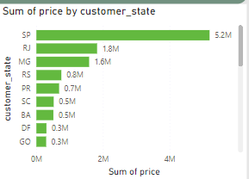

**Sum of price by customer state**

1. **SP** :
   * Sum of Price: **5.2M**
   * Insights:
     + São Paulo is the leading state in terms of sales, significantly higher than other states. This could be due to a larger customer base, higher purchasing power, or targeted marketing efforts in this region.
2. **RJ**:
   * Sum of Price: **1.8M**
   * Insights:
     + The second highest sales, but substantially lower than São Paulo. Indicates a strong market presence but with room for growth.
3. **MG** :
   * Sum of Price: **1.6M**
   * Insights:
     + Close to Rio de Janeiro in sales, suggesting another key market.
4. **RS :**
   * Sum of Price: **0.8M**
   * Insights:S
     + Mid-range sales, indicating moderate market presence.
5. **PR :**
   * Sum of Price: **0.7M**
   * Insights:
     + Similar to Rio Grande do Sul, suggesting consistent but lower sales.

* **Regional Sales Distribution**: São Paulo (SP) dominates sales, suggesting a major focus area or the largest customer base. Efforts to increase penetration in other states, especially those with lower sales figures, could help in further growth.

**7.Seasonal Sales Patterns:**

* + Investigate and visualize any seasonal patterns(Quarterly) or trends in sales data over the course of the year.

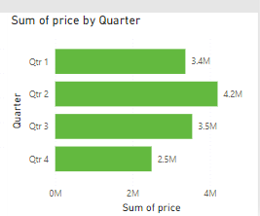

**Sum of price by quarter**

* **Qtr 1**:
  + Sum of Price: **3,400,000**
  + Insights:
    - Qtr 1 has the highest sales, indicating a strong start to the year. Possible reasons could be seasonal promotions, new product launches, or higher consumer spending during this period.
* **Qtr 2**:
  + Sum of Price: **2,500,000**
  + Insights:
    - Sales drop by approximately **900,000** from Qtr 1 to Qtr 2, which is a **26.5%** decrease. This significant reduction might be due to the end of seasonal promotions or other market dynamics.
* **Qtr 3**:
  + Sum of Price: **2,500,000**
  + Insights:
    - Sales remain stable from Qtr 2 to Qtr 3, showing no significant growth or decline. This indicates a consistent performance during the mid-year period.
* **Qtr 4**:
  + Sum of Price: **2,500,000**
  + Insights:
    - Similar to Qtr 2 and Qtr 3, Qtr 4 maintains a steady sales figure. This stability could suggest established market conditions or effective sales strategies keeping the sales consistent.

**Overall insights:**

* **Sales Trends**:
  + The significant peak in Qtr 1 followed by a consistent but lower performance in subsequent quarters suggests that there might be specific events or factors driving high sales in Qtr 1. These could include holiday sales, new product releases, or marketing campaigns.
  + The consistent sales in Qtr 2 to Qtr 4 indicate stability but also highlight the need to identify and leverage opportunities to boost sales in these periods.

**8.Revenue Analysis:**

* + Determine the total revenue generated by ShopNest Store  and analyze how it changes over time(Yearly). Represent this information through suitable visuals to highlight trends and patterns.

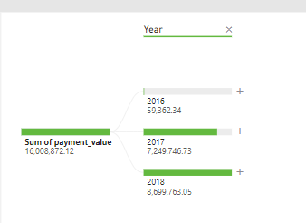

**Sum of payment value by year**

1. **2016**:
   * Sum of Payment Value: **59,362.34**
   * Insights:
     + This year shows minimal sales compared to the following years, suggesting the business was likely in its early stages or there were fewer transactions.
2. **2017**:
   * Sum of Payment Value: **7,249,746.73**
   * Insights:
     + A significant increase from 2016, indicating substantial growth. Sales have increased by approximately **7,190,384.39**.
3. **2018**:
   * Sum of Payment Value: **8,699,763.05**
   * Insights:
     + Continued growth from 2017, with an increase of about **1,450,016.32**. This suggests sustained positive performance and possibly expansion of operations or product lines.

* **Sales Growth**: There has been substantial growth from 2016 to 2018, with the most significant jump between 2016 and 2017. This indicates successful strategies in expanding the customer base, increasing product offerings, or improving marketing efforts.

**RECOMMENDATION**

• **Capitalize on High-demand Months**:

* Leverage strategies from peak performance months like September to improve sales and delivery performance in other months.

• **Improve Product Ratings**:

* Address customer feedback to improve product quality and service in lower-rated categories, such as security_and_services and office_furniture, to enhance customer satisfaction.

• **Boost Q4 Sales**:

* Implement targeted promotions and marketing campaigns to increase sales during Q4, addressing the current drop in performance.